Service Cloud is an easy-to-use customer service application that can help you provide and track excellent service. It keeps your customers happy and your support team sane, whether your customers reach out to you by email, phone, social media, or other channels from desktops, mobile devices, or apps.

You can get started with Service Cloud quickly—with clicks, not code.

Here’s how it works.

**Service Console**  
At the heart of Service Cloud is the Service Console. The console is a help desk that lets anyone on your service team (or anyone at your company) see a personalized view of each customer and their case.  
  
**Case Management**  
A case is a customizable record in Salesforce that tracks and describes a customer issue, complaint, request—you name it. All unifying information about a customer is stored on a case, including account, contact, product, and history data so that anyone on your service team can jump in to help.  
  
**Channels & Digital Engagement**  
Whether the case arrived by email, phone call, web chat, social media, or text message, a support agent can quickly respond to it from the console. Agents can track any useful information and engage with customers on their favorite channels, devices, or apps to provide a great service experience.  
  
**Automatic Workflows**  
When a case arrives, its information is automatically assessed and routed to the right people to match any custom workflows set up for your team. Notifications keep your service team on track before they miss any key items, required responses, or service agreements.  
  
**Knowledge Base**  
Find, share, and store articles or answers related to cases to speed up service. Or, let customers find answers on their own from your self-service help centers or portals.  
  
**Instant Metrics**  
Information about cases is available in service metrics to gauge your business’s response times, resolution times, and overall service health. Use data to identify strengths and gaps; and make decisions on how to deliver better, faster service.  
  
**Mobile & Field Service Ready**  
Since Service Cloud is part of the Salesforce platform, all of your business data, customized processes, and unique workflows come together in one simple place. You can even see it all on your mobile phone or tablet out in the field.  
  
**Service for Everyone**  
Salesforce is committed to providing accessible products for all individuals — including your service team members working with assistive technology, such as speech recognition software and screen readers. Accessibility isn’t a special feature; it’s universally designed into features for Service Cloud.  
  
**Automatic Updates for the Future**  
With each Salesforce release, you automatically get the latest technologies to position your support team for the future and the Fourth Industrial Revolution, including artificial intelligence (AI) for predictive service. And with the AppExchange—a marketplace where you can buy or find free Salesforce applications—you can choose from a variety of apps to help your team and customers.

**Benefits of the Console**

| **Benefit** | **Description** |
| --- | --- |
| (1) Split views | From the start, you can see a list of cases alongside your workspace to quickly work through incoming customer issues. |
| (2) Related record and related list components | Right out of the box, you can see information related to a customer to get a well-rounded picture of their issue and who they are. Jump to lists of similar cases, and work off lists to keep your cases organized. |
| (3) Highlights panel component | Without configuring a thing, spot exactly what you need front and center to respond to customers quickly. |
| (4) Compact case feed | Understand case progression and case history at a glance with a news-like feed and preconfigured pages. Colorful icons help you distinguish between people and interactions instantly, and you can add a quick comment to help your customers or team. |
| (5) Knowledge component | See suggested articles from your knowledge base to solve cases faster, search articles to find exactly what you need, and attach common solutions from similar cases. (You must enable Lightning Knowledge first.) |
| (6) Preconfigured utility bar | Increase productivity with tools, such as Notes to jot things down, or History to go back to recently viewed records. |

Everything you need to quickly respond to customers is preconfigured for you in the console. And with Service Cloud, you can expand your service tools and customizations as your team or company grows.

## Set Up Service Cloud

| **Benefit** | **Description** |
| --- | --- |
| (1) Guided setup flows | Follow a few simple prompts and your email and social channels are up and running, ready to turn customer issues into cases. |
| (2) Service metrics | Glance at a dashboard to monitor your service performance and check on the health of your team and overall customer satisfaction. |
| (3) Recommended setup | Discover simple steps to set up key features, learn more about Service Cloud, and get plugged into the Salesforce community. |
| (4) Setup tree | Explore branches of the setup tree and check out all the features at your disposal. Not all Service Cloud–related setup nodes are exposed in the Service Setup tree—only the essentials—so click around to get to where you want to go. |

## General Setup Process

It doesn’t matter if your org services sundaes or solar panels. The general setup process for Service Cloud is the same. Here’s a high-level view of the process:

1. **Automate case management**—First, route customer questions, comments, and feedback to the right people and places with as little work as possible. Analyze service metrics to spot trends and make better choices about service.
2. **Add multiple channels**—Once your case management system is in place, engage with customers on their favorite communication tools, such as phones, emails, websites, social media, and more. Sync all your channels to a console so that your team can respond to customers anywhere.
3. **Capture knowledge**—As customer engagement provides your team with insights, store all useful information in an easy-to-search Knowledge base so helpful articles are just a click away for support agents or customers.
4. **Expand efficiencies with AI**—Finally, include artificial intelligence and bots to streamline more tasks and predict service before it’s needed.

Think of the setup process as circles of service expansion. Case management is the core. Then expand the core with channels, knowledge, AI and bots.

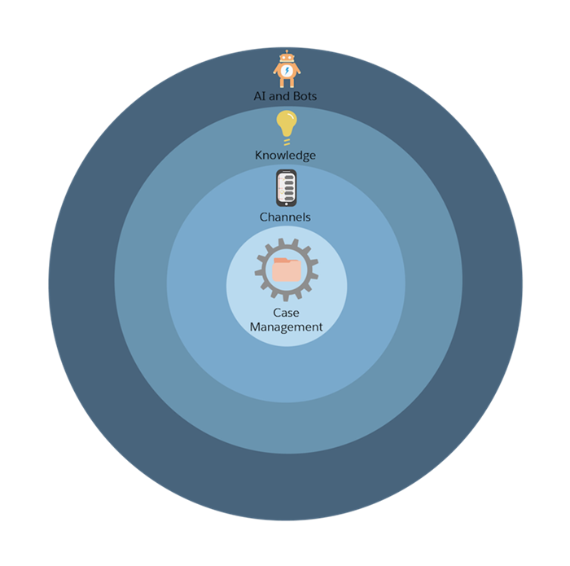

## Case Management Tools

Case management means organizing customer cases into one place and making sure they go to the right person, for the right answer, by the right time. Service Cloud does all that behind the scenes with automation tools. Service is easier, faster, and better with a little auto-magic.

|  |  |
| --- | --- |
| Queues | Automatically prioritize your support team’s workload by creating lists from which specific agents can jump in to solve certain types of cases. |
| Assignment Rules | Automatically assign incoming cases to specific agents so that the right people work on the right cases. |
| Escalation Rules | Automatically escalate cases to the right people when the cases aren’t solved by a certain time. |
| Auto-Response Rules | Automatically send personalized email responses to customers based on each case’s details. |

## Plan for Case Automation

| **Question** | **Answer** | **Tool** |
| --- | --- | --- |
| Do support agents work as a team on specific issues? | Yes, some agents work off a list of emails as they arrive from customers. | Queues |
| How is the support team structured? | We have Gold and Platinum support teams. Platinum support shares a workload. | Queues  or  Assignment Rules |
| Do support agents work on specific products or have special skill sets? | Some agents work on solar panel installation while others work on solar panel performance. | Assignment Rules |
| Do cases need to escalate to someone if they’re not solved by a specific time? | Yes, we can’t have customers waiting more than 5 hours to get their issues solved. | Escalation Rules |
| Should customers receive automatic responses? | Yes, we want customers to know that we received their issue and that we care about them. | Auto-response Rules |

## More Case Management Tools

|  |  |
| --- | --- |
| Page Layout Editor | Customize a case page’s contents, like the fields and buttons that appear on the page, along with what is visible to whom. Additionally, customize the structure of the page, and the position of its components, with the Lightning App Builder. |
| Email Templates | Create email templates to save time and standardize communications sent to customers from cases. Automate information on emails with merge fields. Templates are automatically available to anyone in the org. |
| Entitlement Management | Provide the correct level of support for customers. Define, enforce, and track service agreements and service contracts as part of an overall support management process. |
| Omni-Channel | Manage support agents’ priorities and their capacity to take on work items so that they’re given only the number of assignments that they can handle. Route all assignments to the correct agents so that they no longer have to choose work assignments manually from a queue. |
| Macros | Help support agents automatically complete repetitive tasks on cases, such as selecting the right email templates, so that they can spend time doing more important things. |
| Quick Text | Create predefined messages for support agents, like greetings, answers to common questions, and short notes to insert in cases, emails, web chats, and more. Save time and standardize on messaging to customers. |
| Utilities | Give support agents quick access to productivity tools, like notes, history, softphones, and more in the footer of the console. |